Shoulder problem poses – understanding anatomy to prevent injury.

As a physiotherapist and yoga teacher, I have seen many shoulder injuries
Cause by a lack of mindfulness in daily activity and/or poor technique in asana. When I commenced yoga practice at the end of 1993, I was delighted to discover a correlation between physiotherapy and yoga practice. However, since that time, I have observed a general absence of instruction regarding the shoulder, which can unintentionally injure rather than strengthen the area. Traditional emphasis is placed on protection of the hips and knees, leg alignment and general posture with little importance on the upper body, particularly shoulder function. Yoga asana should be utilized to prevent and manage shoulder injuries rather than initiate them, so during the past fifteen years of working intensively combining physio and yoga, I have had the opportunity to develop strategies to prevent injury and manage shoulder pain.

Some shoulder problems may be due to a specific injury that requires appropriate medical
treatment; but others may be chronic problems, for which standard treatment has been limited.
It may also be that the problem begins to develop in the class, due to poor and uncorrected
patterns of movement in asana. It is hoped that by offering a greater understanding of
shoulder anatomy the shoulder joint will be a lot happier in a yoga class.

Some of the most common problems in the shoulder are:
- Rotator cuff tendon tears
- Impingement of tendons
- Tendonitis – inflammation of tendons of muscles around the shoulder
- Muscle imbalances

The Shoulder Joint Complex
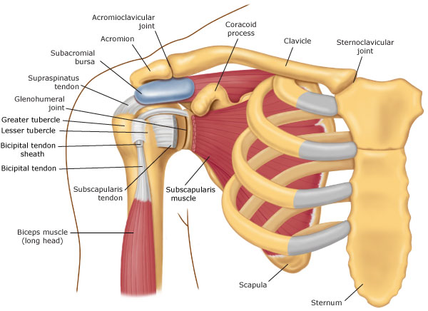
The shoulder joint is by nature a flexible joint; the flexibility is contained somewhat by the soft
tissues around the joint, including ligaments (join bone to bone) and tendons (join muscle to
bone). The joint is made up of a few different bones, forming a complex of 4 joints. The arm
bone (humerus) sits in a bony socket which is part of the shoulder blade (scapula) forming one
joint. The bony socket in which the arm bone sits is not very deep, potentially allowing a lot of
movement. It is deepened a little by a cartilage cuff. The arm bone attachment to the shoulder
blade is reinforced by the shoulder muscles. The second joint is between the shoulder blade
and the back of the chest, held in place by muscles attaching to the ribs and spine. The final
two joints are the where the collarbone meets the shoulder blade - the bony top of the
shoulder and where the collarbone meets the sternum. These last two joints are significant
but their contribution to shoulder function in the content of this article is negligible and
therefore will not be discussed.

Rotator cuff sprains and tears
Generally as a result of a fall, a throw or by lifting something heavy the muscles and tendons
that stabilise the shoulder joint and lift the arm can be damaged or torn. Inability to use the shoulder normally may result. If extreme damage is done surgery may be required to repair; either way the injured tissues will heal in 2-3 months.

Impingement
Shoulder impingement may occur following an injury or when there is some muscle imbalance
in the shoulder (see below). The tendons that may get impinged are those that pass under the
bony top of shoulder, squeezing through a tight gap above the arm bone. A catch of pain is
often experienced when lifting the arm up or taking it behind the back.

Tendonitis
Tendonitis is inflammation of the tendon. Tendons become inflamed when they are irritated
by surroundings structures. This can happen in the case of impingement. Inflammation can
result in a more constant ache and pain. Sometimes the fat pad that sits between the tendons
and bone may also get inflamed - (bursitis).

Muscle Imbalance
Many of the aforementioned problems cause, or are caused, by muscle imbalance around the
shoulder. Shoulder functioning is achieved by the intricate timing and co-ordination of a
number of muscles. Tight muscles will create unbalanced pull in their direction and weak
muscles will be unable to counter this or control the usual movement.

To Move the Arm
The action of taking the arms above the head may appear easy, but it actually involves the coordinated movement of the arm bone in the shoulder socket and the movement of the
shoulder blade on the back of the chest.
♦ About 2/3’s of the movement happens between the arm bone and shoulder blade; 1/3
between the shoulder blade and chest wall.
♦ Additionally the natural movement of the arm in the shoulder joint involves the arm
bone moving up and pivoting in the joint to create a turning out.
♦ As the arm bone moves, its head slides down at the joint interface.
This pattern of movement ensures that the tendons that run in the tight space at the front of
the joint do not get pinched and irritated. Following an injury to the shoulder it is important that
this natural rhythm is regained.

Muscular pulls on the shoulder blade
The muscles running from the neck to the shoulder blade lift it up. These muscles are prone
to tightness and overactivity, particularly with a sedentary lifestyle (time spend in front of
computers) and stress (carrying the world on our shoulders). The muscles between the middle
back and shoulder blade pull the shoulder blade down and are generally prone to weakness.
Sometimes the shoulder blade can be seen to ‘wing’ out (see picture). Ideally there is a
balanced action of these muscles that allow a nice turning out of the shoulder blade as the
arm rises, quite like the movement of a dial.

Muscular pulls on the arm bone
The group of muscles that connect the shoulder blade to the top of the arm bone are
collectively known as the rotator cuff muscles. These muscles work in a co-ordinated manner
to control the movement of the head of the arm bone in the shoulder socket. Again as the arm
bone moves upward these muscles slide the head of the bone down at the joint interface,
keeping it centred in the socket. The rotator cuff muscles can be prone to tightness and
weakness, also leading to imbalance in their action.

Flexibility in the spine
The function of the shoulder joint complex is also influenced by flexibility in the spine. If you
allow your body to slump and try to take the arms above the head, you’ll notice it is quite
difficult. Instead if you lift your chest (extend the thoracic spine), this movement becomes
easier. This is because “the arm bone’s, connected to the shoulder bone; the shoulder bone’s
connected to the ribcage; the ribcage’s connected to the thoracic spine” and so on.

Asana specifics to help shoulder problems
Many of these problems arise due to an imbalance around the joint. Such imbalances are
addressed beautifully in yoga asana. Try the following practice with simple variations to poses
to:
- Increase flexibility in spine
- Strengthen shoulder muscles
- Improve awareness and co-ordinated movement
- Relaxation/ Meditation

4 point kneeling
Even for a strong experienced student, returning to 4-point kneeling can be helpful in order to establish stability and awareness of more subtle movements. Keep the shoulders broad; grip the shoulder blades into the back of the chest.
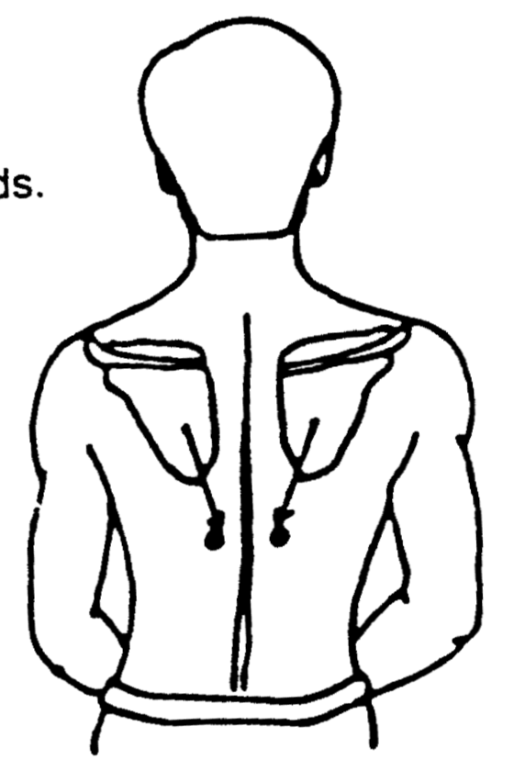
Plank Pose
Maintain this strong arm and shoulder blade action as you walk the knees out into kneeling or full plank pose. Be aware of any asymmetry across the shoulders and excessive movement of the shoulders forward. Draw the shoulders and shoulder blades down to feel the strength of the upper arms.
Dog face down
Lift up and slowly move from plank pose into dog face down with the knees bent. Be aware as your approach the fullness of the pose of the tendency for the shoulders to rise to the ears. Instead keep the shoulder blades down and broad; keep the armpits turning to face each other; allow the neck to ascend through the shoulders. If your shoulders are tight you may not get so far, but particularly if you’ve had shoulder or neck problems this technique will be of greater benefit to you.
Warrior I
Step forward with one leg, hips facing the front leg. Bring the palms together at the heart space. Breathe in and take the arms up, turning the palms and elbow crease to face back, bring the elbows in, draw the shoulders down. Lengthen through the arm in both directions. Preserve the line of the spine; broaden across the front of the chest and shoulders. Don’t be in a hurry to come to the fullness of the movement, lift the chest and lengthen through the thoracic spine. The exact same position can be reached with movement of the arms from the side of the body.

Warrior II
Breathe out and turn through the hips and back leg into Warrior II. Instead of facing the palms down – turn them to face up and pull the shoulder down against the resistance of the neck muscles.

Try to keep the elbow crease facing up as you turn the palms down; draw the arm bone into the back of the shoulder. Keep the palms down turn the elbow crease to face down and then up again. This last action engages the rotator cuff muscles in their turning capacity, quite a feat at this range of movement. To keep the palm facing down, it is the forearm that turns in and out.

Headstand
A pose that might feel quite scary for a beginner, a study¹ showed that headstand is a great pose to activate the rotator cuff muscles. Subjects in the study experienced pain and loss of movement. They performed a modified headstand (for beginners) for 30 sec daily for 6 weeks. The technique needed the subject to be vertical and the focus was on broadening and lifting the shoulders. Nine out of the ten subjects reported improvement in movement and pain. Investigation identified that a change in the pattern of activation of muscles in the inversion enabled this improvement in condition. (Before performing headstand be aware of medical contraindications for inversions).
The critical point of asana practice is to do no harm. The focus outlined in this article is respectful of anatomy and normal shoulder mechanics. The practice of identifying imbalance and abnormal movement can contribute to the prevention of injury. Irrespective of a past injury that may still cause pain and loss of function, this focus may also help to improve the condition. This practice does not replace medical opinion and when an injury is acute, a consultation is advisable to determine the best way forward. May all shoulders be happy ☺.

References
1. Fishman Loren M, Konnoth Caroline & Polesin A. “Headstand for Rotator Cuff Tear: Shirshasana or Surgery”. International Journal of Yoga Therapy 2006; 16: 39-47

